**Freelancing Application MERN**

### Freelance finder: discovering opportunities, unlocking potential

# **INTRODUCTION**

* **Theme Name :**Job Listing
* **Author :**misbahwp
* **Support Forum :**<https://wordpress.org/support/theme/job-listing/>
* **License :**[GNU General Public License v3 or later](https://demo.misbahwp.com/docs/job-listing-free-docs/)
* **Discription :**Job Listing WordPress Theme is a versatile, innovative solution designed for creating dynamic job posting sites and career sites. Built for recruitment agencies, staffing solutions, and online hiring platforms, this theme caters to a wide range of industry-specific jobs including creative jobs, media jobs, construction jobs, architecture jobs, manufacturing jobs, retail jobs, security jobs, and nonprofit jobs. Whether promoting entry-level jobs, internship jobs, graduate jobs, or high-paying executive jobs, this theme offers a sleek, modern job board website complete with resume submission, applicant tracking, and candidate search features. Engineered as a comprehensive job application platform, it streamlines the hiring process with intuitive design and functionality that supports urgent job hiring, job alerts, personalized job recommendations, and AI-powered job search capabilities. Employers enjoy enhanced employer branding and talent acquisition, while job seekers benefit from digital job search tools, remote job listings, and modern hiring techniques. The theme also incorporates features for resume writing services, interview tips, and career counseling to aid professional growth and career advancement. Its visually appealing design, clean layout, and responsive elements ensure an exceptional user experience on every device. Ideal for job posting sites, job board websites, recruitment websites, and employment classifieds, the Job Listing WordPress Theme delivers robust performance, efficiency, and style

# **How to Establish the Theme**

Setup Theme

Template installation is very simple process.

**You can also install your theme using WP Admin**

The first task is to log in to your WordPress admin area. Next, click on

1. In dashboard click on **Appearance >> Themes**

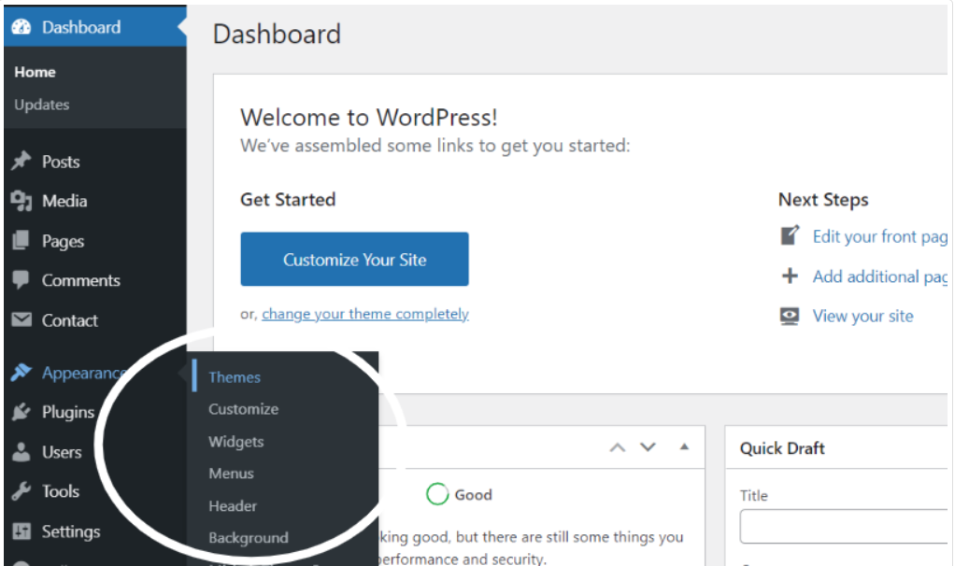

2. Click on the Add New button at the top of the themes page once page is loaded.

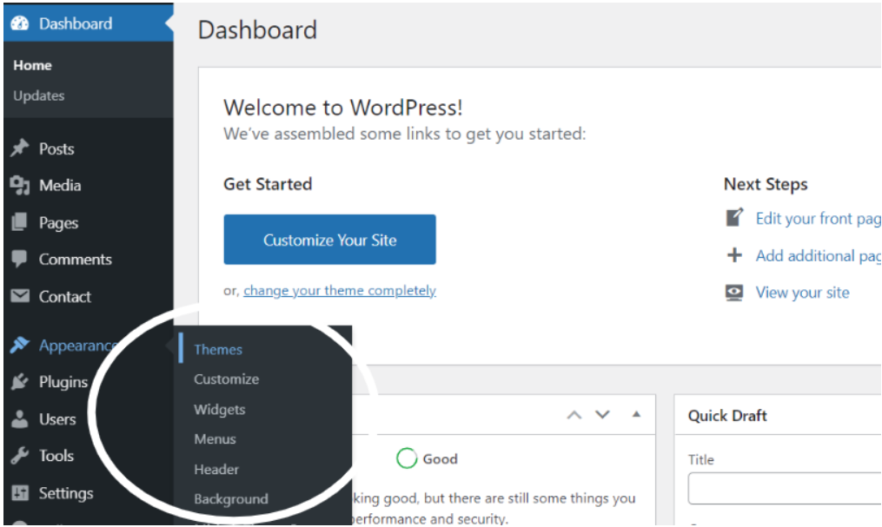

3. Click the button labelled as 'Upload Theme'.

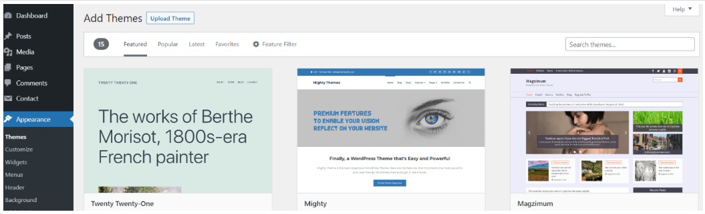4. Click on Browse Button then select your job-listing.zip theme and click on install now button.

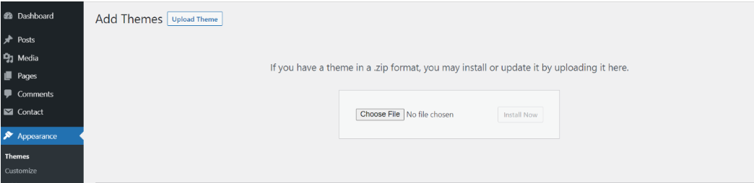

5. WordPress will now install your theme and display a success message, as well as a link to activate or to see the live preview. Congratulations on completing the installation of your theme.

**Demo Importer**

Follow below instructions to setup job-listing theme.

In the Dashboard, go to **Appearance >> Get Started**

Once you are on the Get Started, click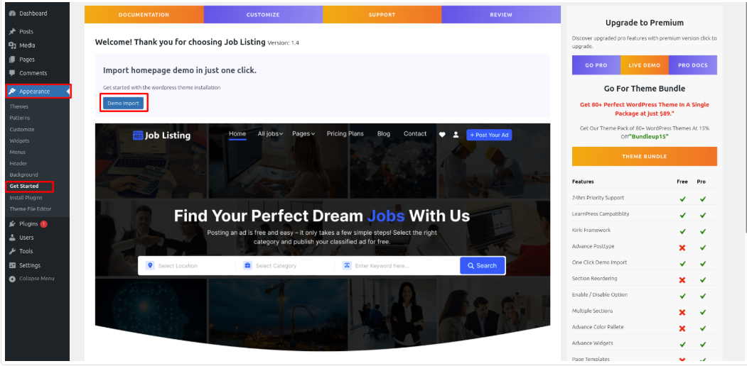 on the **Demo Import** button.

As the demo importer process finish then check your site, all the content will imported and theme will display like live demo.In front end, it will look like this.

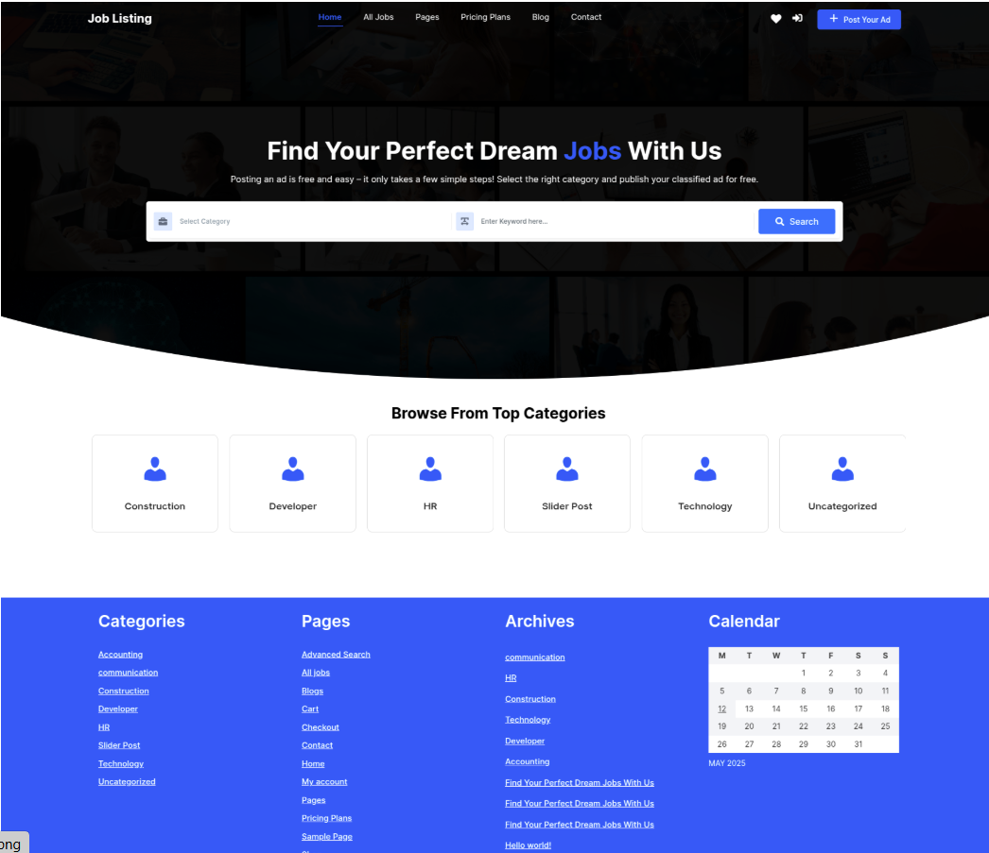

# **Configure Menu**

Configure Menu

In the dashboard, visit **Appearance >> Menu**

To access the Menu Editor, visit the Dashboard and click on the 'Appearance' menu on the left-hand side. From there, select the 'Menus' option.

To create a new menu, follow these steps:At the top of the page, select "Create a new menu".Enter a name for your new menu in the "Menu Name" box.Click on the "Create Menu" button.

Your new custom menu has been successfully created.

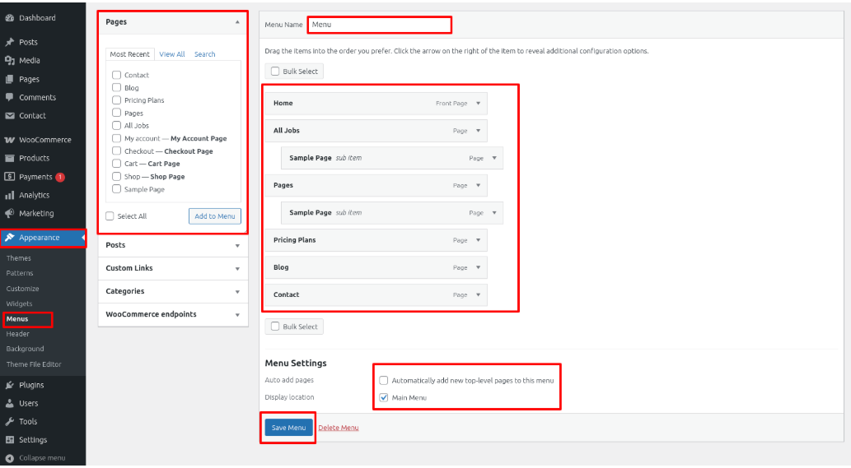

On the front end, the menu will appear as follows.

Job Listing Free Theme Setup

# 

# **Job Listing Free Theme Setup**

Configure Header

In order to proceed with You can set top header text and header button , so follow the below steps.

In the dashboard, go to **Appearance >> Customize >> Theme Options >> Header Settings**

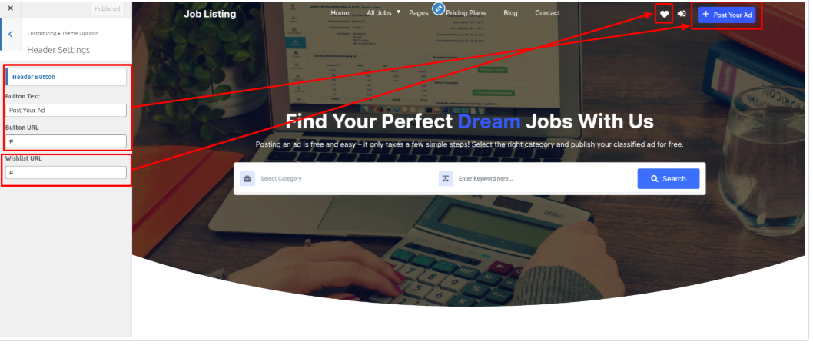 In front end, it will look like this.



# **Logo Setup**

In order to proceed with Theme Logo setup, you can set site title and tagline, follow the below steps.

In the dashboard, go to **Appearance >> Customize >> Site Identity >> Set Logo , Site Title and Tagline**You can also make the tagline hidden.

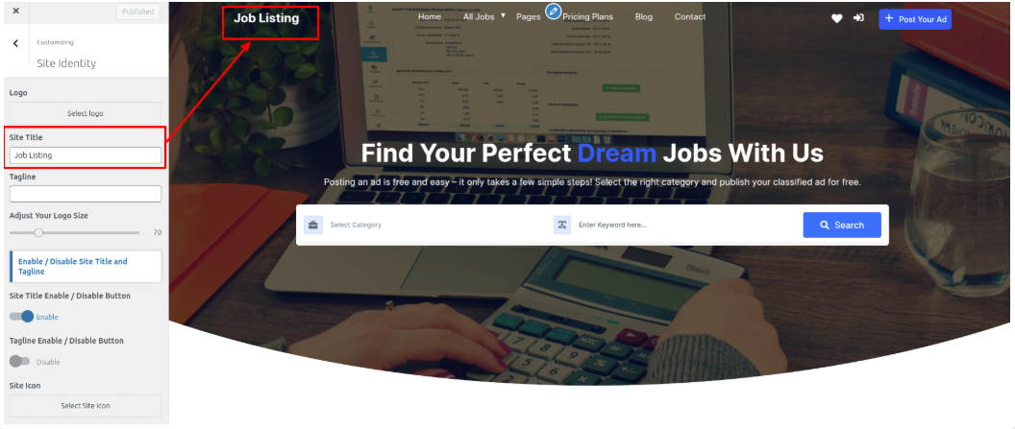

In front end, it will look like this.



# **Slider Section**

## Fetch Categories

This screen is divided into 2 sections, the Add New Category and category table sections.

All of the categories are listed in this table. Categories are organized alphabetically and hierarchically.

In order to proceed with Theme social icon, so follow the below steps.

Follow the below steps to setup Category Settings.

In the dashboard, go to **Posts >> Categories >> Add New**

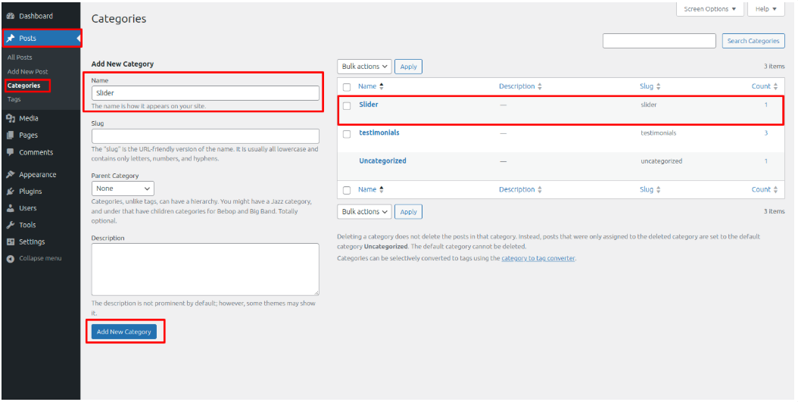

Once you have done with this you will see the categories on your theme customize.

In this section, you have to add new category for each post.

Fetch Post

In the dashboard, go to **Posts >> Add New**

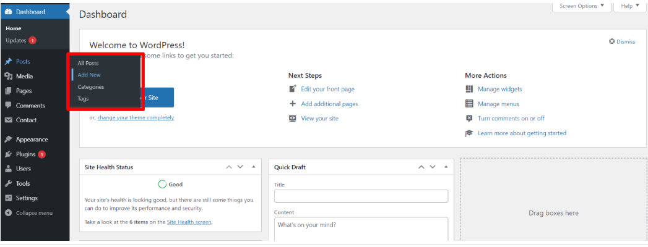

In order to proceed with Post Settings, You can set post title and content. And Select which Category you want this post to show.

Follow the below steps to setup Post Settings.

In the dashboard, go to **Posts >> Add New**

You can make multiple posts for category.

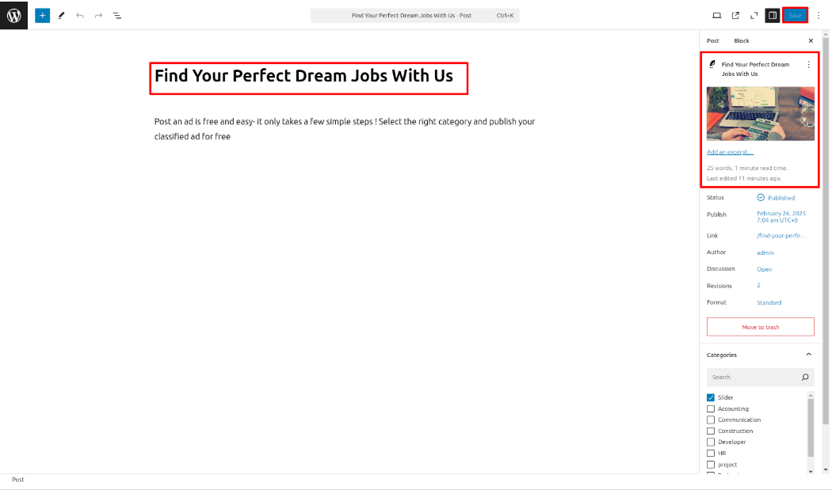

Once you have done with this you will see the post on your front page.

# **Slider Settings**

In order to proceed with Theme Slider Settings , you can set slide show , follow the below steps.

In the dashboard, go to **Appearance >> Customize >> Theme Options >> Slider Settings**

Select number slides to show, then select the category which you have to show on slider.

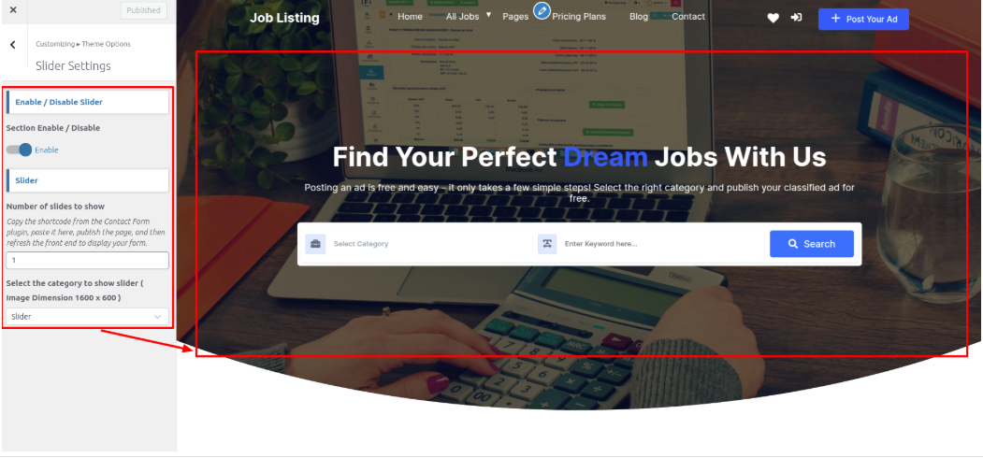 In front end, it will look like this.

# **Top Categories Section**

## Fetch Categories

This screen is divided into 2 sections, the Add New Category and category table sections.

All of the categories are listed in this table. Categories are organized alphabetically and hierarchically.

Follow the below steps to setup Category Settings.

In the dashboard, go to **Posts >> Categories >> Add New**

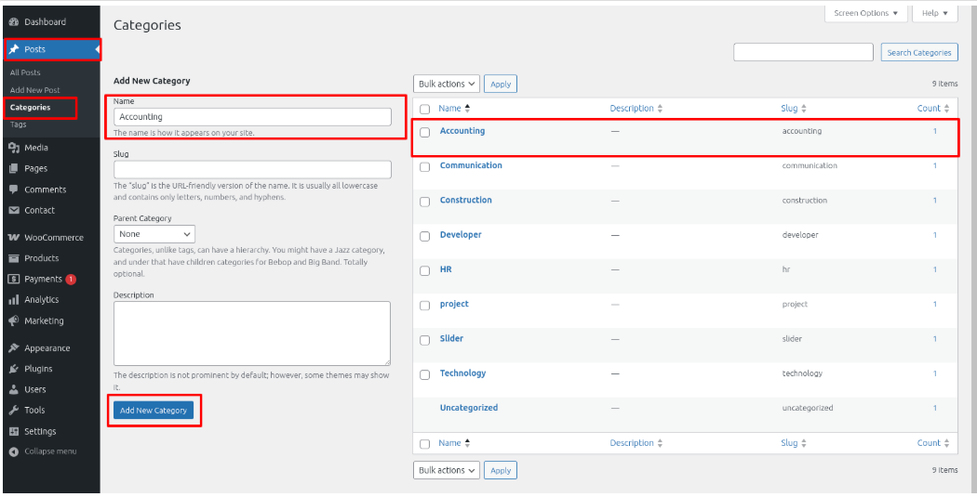 Once you have done with this you will see the categories on your theme customize.

In this section, you have to add new category for each post.

# Fetch Post

In the dashboard, go to **Posts >> Add New**

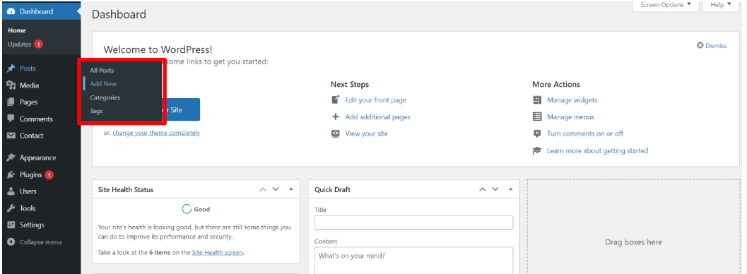 In order to proceed with Post Settings, You can set post title and content. And Select which Category you want this post to show.

Follow the below steps to setup Post Settings.

In the dashboard, go to **Posts >> Add New**

You need to create a post and then assign the categories you made to that post and publish it.

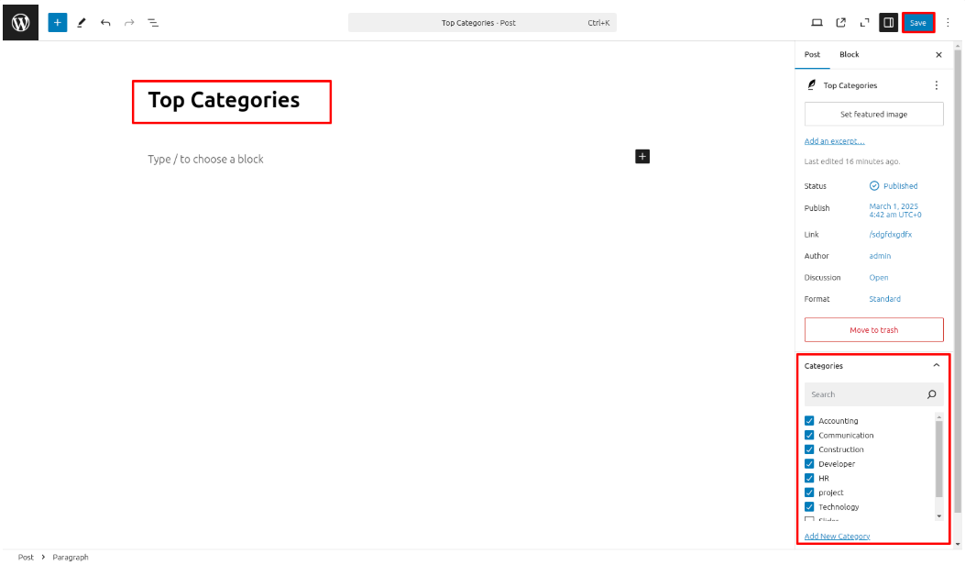

Once you have done with this you will see the post on your front page.

# **Top Categories Settings**

In order to proceed with Theme Top Categories Settings , you can set post to show , follow the below steps.

In the dashboard, go to **Appearance >> Customize >> Theme Options >>Top Categories Settings**

Select number Top Categories to show, then select the category which you have to show on Top Categories .

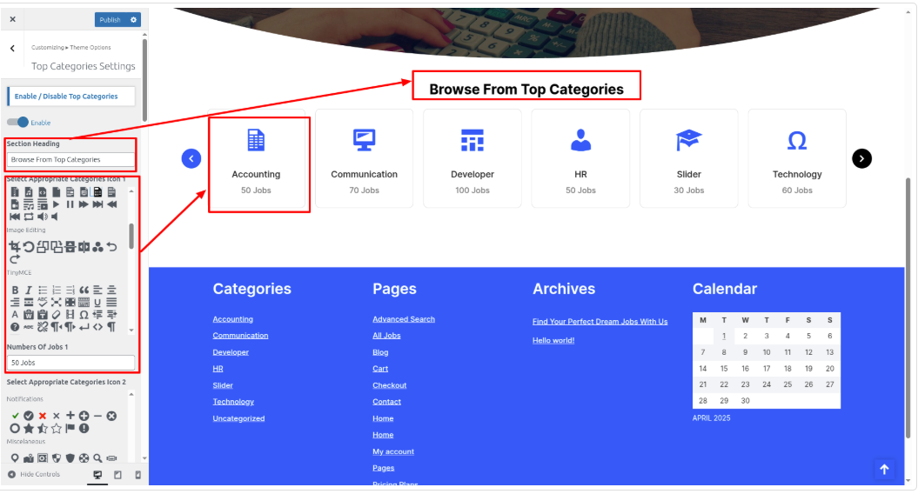

In front end, it will look like this.

# 

# **Setup Footer Section**

There are four columns in the footer. Any widget can be added there..

**For Adding widgets first you have to add classic widget plugins**.

1. In the dashboard, go to**Appearance >> Widgets**

To add widgets to the footer, see the screenshot below.

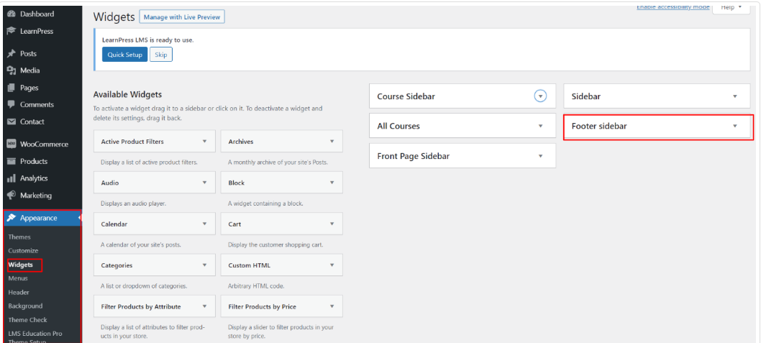 You can add footer coloumns, for that you need to select widgets like text, image, gallery, etc which allows you to add text or image as per your choice with ease.

In order to manage content for footer and add some widgets, navigate to, follow the below steps.

2. In the dashboard, go to **Appearance >> Widgets >> Footer Sidebar**

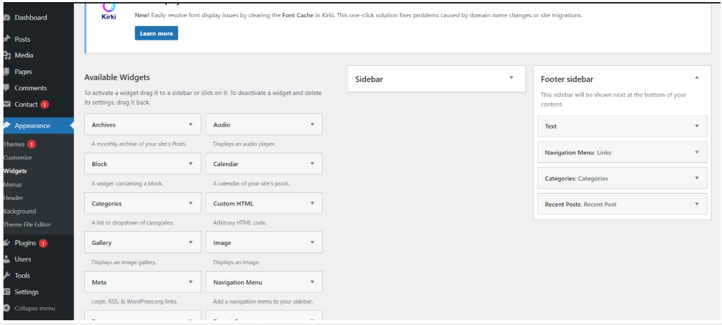 Your footer will appear like this once you have added widgets to it.

# 

# **Footer Copyright Text**

In order to proceed with footer Settings, You can fill the copyright content to footer copyright Settings.

5. In the dashboard, go to **Appearance >> Customize >> Theme Options >> Footer Setting**

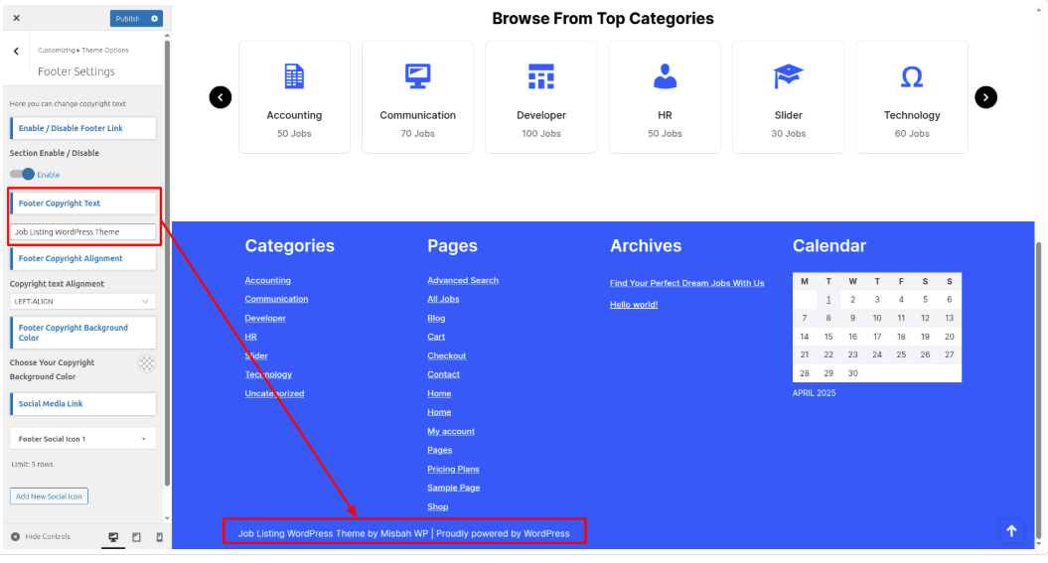 In front end, it will look like this.

